12 Å boundary

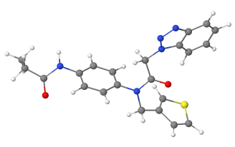

Ligand

The Ligand is any set of atoms that represents the site of interest, typically a molecule or a set of residues.